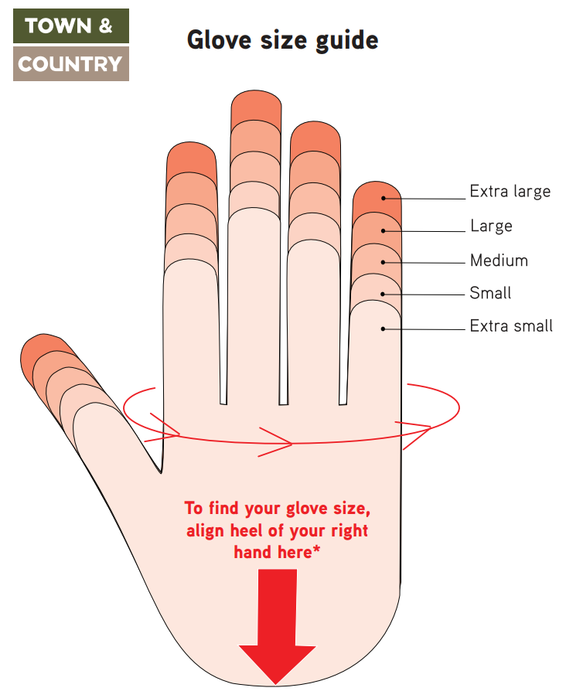

Alternatively, measure the diameter of your hand in inches
(below your 4 fingers as shown by arrow).
